INSPECTION EQUIPMENTS

GRANITE SURFACE PLATES

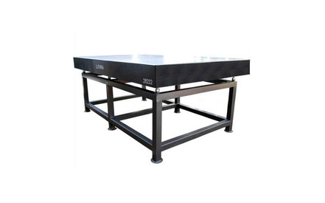

Granite surface plates are manufactured using natural black granite stone, quarried from earth in its natural form. These plates are precision lapped to high standards of flatness to achieve accuracy and are used as bases for mounting sophisticated mechanical, electronic and optical gauging systems. Our quality inspectors and engineers put a strict vigilance at all the stages of the production procedure to ensure high quality plates. Further, the final inspection is carried out by a High Precision Computerized Electronic Level made by WYLER OF SWITZERLAND. Our range of Granite surface plates are utilized in Precision tool rooms,
Engineering industries and Research laboratories.
Some of the unique features of our range of plates are:
- Uniformity in Hardness
- Accurate under load conditions
- Vibration absorbent
- Easy to clean
- Rust-proof ,Non-corrosive
- Thermal stability
- Wrap resistant
- Low porosity
- Non-abrasive ,non-magnetic

These advantages make black granite surface plates inherently stable and unmatchable against any other material.
These plates are supplied with computerized calibration certificate traceable to National Physical Laboratory (NPL, Govt Of India ) New Delhi .Rexin covers are provided with each surface plate for protection of top surface .

We provide fabricated stand with leveling screws on request by our clients. The overall working height of surface plates with stand and levelling screw will be 900 MM (approx) from floor level.

SIZE OF PLATE | FLATNESS TOLERANCE IN um, FOR ACCURACY GRADE
 | 00 | 0 | 1 | 2 | Weight in Kgs (approx)
250 X 250 | 2 | 5 | 12 | 25 | 10
300 X 300 | 2 | 5 | 13 | 26 | 22
400 X 250 | 3 | 5 | 14 | 28 | 20
400 X 400 | 3 | 6 | 14 | 28 | 40
500 X 300 | 3 | 6 | 15 | 30 | 35
630 X 400 | 3 | 7 | 18 | 32 | 65
630 X 630 | 3 | 7 | 18 | 32 | 100
800 X 500 | 4 | 7 | 18 | 36 | 120
1000 X 630 | 4 | 8 | 20 | 40 | 320
1000 X1000 | 4 | 8 | 20 | 40 | 500
1200 X 800 | 5 | 8 | 22 | 44 | 475
LARGE SPECIAL SIZE AVAILABLE ON REQUEST

CAST IRON SURFACE PLATE

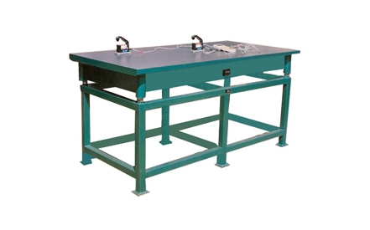

We offer a qualitative range of Cast iron surface plates. These plates provide an accurate reference plane for precision gauging, inspection and tooling setup.
We make use of good quality closed grain cast iron that is as per the IS 210:1993 confirming to Grade FG-220.The meticulous manufacturing processes that are carried out at our premise makes these cast iron plates apt for machine shops, quality control and standard rooms. Our cast iron plates are utilized in the applications, where strict accuracy
required hence, these plates are appropriate for high precision work and are ideal for blue matching.
We lay a lot of emphasis on the quality and traceability of our Cast iron plates. Our team of qualified engineers carries out rigorous quality control inspection to test these plates on the criteria of flatness and efficiency. The final inspection of these plates is undertaken by a High Precision Computerized Electronic Level make WYLER OF SWITZERLAND. Some of the unique features of our range of Cast Iron plates are:
- Our castings are stress relieved either by natural ageing or by artificial seasoning
- A protection covering of Rexin or wood is provided on the top surface of each and every plate

- We offer fabricated stand with leveling screws on the l request of our esteemed clients. The overall working height of surface plate with stand and leveling screw will be 900 MM (approx), from floor level
- We supply Surface plates with computerized calibration certificate traceable to National Physical Laboratory (NPL, Government Of India ) New Delhi
- SpecialProvision
We provide special tapped holes and T-Slots at the top working surface for fixing work or measuring instruments at extra cost. These are offered as per customers’ specifications.
Tolerances on overall deviation from flatness in microns as per International Standard ISO 8512- 1:1990 / Indian Standard 2285:2003

Sizes  L x B x H mm | Grade 0  Um | Grade 1  Um
250 x 250 | 3.5 | 7
400 x 400 | 4.5 | 9
630 x 400 | 5 | 10
630 x 630 | 5 | 10
1000 x 630 | 6 | 12
1000 x 1000 | 7 | 14
1200 x 600 | 7 | 14
1200 x 900 | 7 | 14
1200 x 1200 | 8 | 16
1600 x 1000 | 8 | 16
2000 x 1000 | 9.5 | 19
1200 x 1800 | 9.5 | 19
LARGE SPECIAL SIZE AVAILABLE ON REQUEST.

CAST IRON BENCH CENTRE

CAST IRON BENCH CENTRE

RATCHET PIPE THREADER (BSPT)

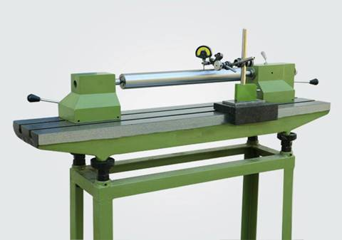
Features:
- Bench Centre is ideal for checking of run-out, concentricity. Parallelism and axial run out of components.
- The Base of Bench Centre and its heads are artifically stress Relieved.
- One of the centre is spring loaded to ensure uniform pressure while holding work pieces and easy loading and unloading without disturbing the accuracy of centres.
- Both heads are adjustable to the required position easy and quick setting of the required distance between centres.
- The heavy duty bed is provided with two T-Slots, Parallel to each other.
- Base of the Bench Centre is made of close grained casting and finished to high degree of accuracy by hand scrapping.

Specifications:
Model | Sizes  mm | Centre  Distance  mm | Centre Height  mm | Co-axiality of  Centres  Microns  um | Parallelism of the  axis of the centre  With respect to  guide ways
BC-3 | 300 x 125 | 300 | 125 | 10 | 10um/300 mm
BC-3 | 300 x 160 | 300 | 160 | 10 | 10um/300 mm
BC-5 | 500 x 160 | 500 | 160 | 15 | 10um/300 mm
BC-5 | 500 x 200 | 500 | 200 | 15 | 15um/300 mm
BC-7 | 750 x 160 | 750 | 160 | 20 | 10um/300 mm
BC-7 | 750 x 200 | 750 | 200 | 40 | 15um/300 mm
BC-10 | 1000 x 160 | 1000 | 160 | 20 | 10um/300 mm
BC-10 | 1000 x 200 | 1000 | 200 | 40 | 15um/300 mm
BC-12 | 1250 x 160 | 1250 | 160 | 20 | 10um/300 mm
BC-12 | 1250 x 200 | 1250 | 200 | 40 | 15um/300 mm
BC-15 | 1500 x 160 | 1500 | 200 | 20 | 10um/300 mm
BC-15 | 1500 x 200 | 1500 | 200 | 40 | 15um/300 mm
BC-20 | 2000 x 200 | 2000 | 250 | 40 | 15um/300 mm
BC-20 | 2000 x 250 | 2000 | 250 | 40 | 15um/300 mm
BC-25 | 2500 x 250 | 2500 | 300 | 40 | 15um/300 mm
BC-25 | 2500 x 300 | 2500 | 500 | 40 | 15um/300 mm
BC-25 | 2500 x 500 | 2500 | 125 | 60 | 20um/300 mm

Cast Iron Lapping Plates

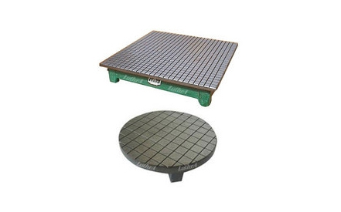

We supply a wide range of Lapping plates that are manufactured using good quality raw material. These lapping plates are used for precision lapping of components of various sizes. These components are lapped using lapping powder of different grits to achieve finish and accuracy. Our
lapping plates both granite and cast iron are made as per standards.
Our range of lapping plates includes cast iron lapping plates and granite lapping plates.

We provide our clients with qualitative cast iron lapping plates that are used for accurate hand lapping of various materials like nylon, plastics, ceramics and other non ferrous material. These cast iron lapping plates are available in round and rectangular sizes and have 3 mm wide and 3 mm deep serrations on working surface equally spaced at 25 mm. Our iron lapping plates are manufactured using closed grain graded casting as per IS 210:1993 confirming to Grade FG- 220. Cast iron lapping plates are supplied with calibration certificate traceable to National Physical Laboratory (NPL, Govt of India) New Delhi. We offer our range of lapping plates for various lapping machine of different sizes as per the specification of our clients.
Standard Size and accuracy of Cast Iron Lapping Plates as per IS : 2285:2003, Grade 1

Cast Iron Lapping Plates (As Per IS: 2285-2003 )

SQUARE (m.m.)
300 X 450
450 X 600
600 X 600
600 X 900
1000 X 1000

ENGINEER'S STRAIGHT EDGES (STEEL) FLAT SECTION
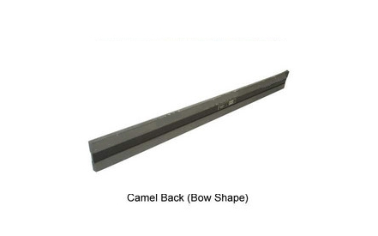 | These Straight Edges are made of alloy Steel and are hardened and ground. The working Surfaces are hand scrapped. All finished surfaces are protected by protective coating and is supplied in a case.

ENGINEER'S STRAIGHT EDGES ( STEEL) FLAT SECTION
Sizes in mm
Length | Width | Thickness | Accuracy mm
300 | 50 | 8 | 0.003
450 | 50 | 8 | 0.003
600 | 50 | 8 | 0.004
1000 | 50 | 10 | 0.007
1200 | 55 | 10 | 0.007
1500 | 65 | 12 | 0.008
2000 | 65 | 12 | 0.010
2500 | 65 | 14 | 0.020
3000 | 85 | 18 | 0.025

SLOTTED ANGLE PLATE

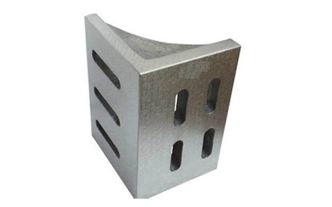

We manufacture and supply a wide range of slotted angle plates, which are largely used in various industries for clamping and holding work in vertical position. These slotted angle plates are also used as a vertical reference for inspection and tooling purposes such as shaping, planning, milling, grinding, drilling etc. All 6 working faces of our angle plates are hand scrapped to desired accuracy and are square/right angle to each other. Fabricated using high quality closed grain cast iron of Grade FG-220, these angle plates comply with IS 2554:1971 standards.
Features :
- Castings are stress relieved either by natural ageing or by artificial seasoning and hand scrapped for surface finish of Grade-1 accuracy
- Angle plates of sizes above 300 mm are webbed to ensure rigidity
- Slots are machined for easy clamping
- Angle plates are supplied with calibration certificate traceable to National Physical Laboratory, New Delhi

Size in mm  L X B X H | Flatness  In Micron | Squareness  In micron | Parallelism of  Opp . Surface
125 X 75 X 100 | 5 | 10 | 13
175 X 100 X 125 | 5 | 13 | 15
250 X 150 X 175 | 8 | 15 | 18
350 X 200 X 250 | 8 | 18 | 20
450 X 300 X 350 | 10 | 18 | 20
600 X 400 X 450 | 10 | 20 | 23
Size Other Than IS
150 X 150 X 150 | 5 | 13 | 15
200 X 200 X 200 | 8 | 15 | 18
250 X 250 X 250 | 8 | 15 | 18
300 X 300 X 300 | 8 | 18 | 20

WHEEL BALANCING STAND ROLLER TYPE

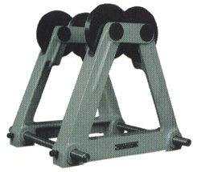 | Technical Details
  Frame | : | Made out of Cast Iron
  Rollers | : | Made out of good quality case hardennig steel (HRC 58-60) and precision ground.
  Sizes | : | 1) 400 mm
   |  | 2) 800 mm Maximum Wheel Diameter
  (While ordering, please specify maximum wheel dia. required.)

SINE BENCH CENTRE

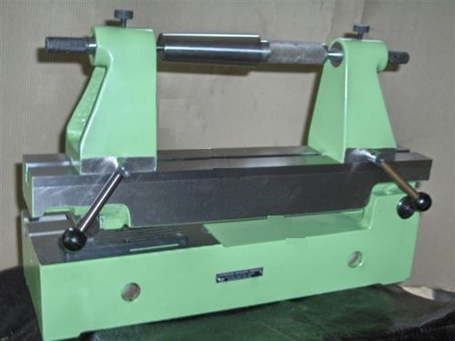 | Technical Details:  The top and bottom plates and centre blocks are manufactured out of heavy duty close grained cast iron having BH 190-21O.  These castings are stress relieved after rough machining before finish machining. Finally these are fine finish ground/hand scraped to give the required degree of accuracy.  The roller and slip gauge platform are manufactured out of Chrome alloy steel hardened to RC 58-60.  These are stabilized after rough grinding before finish ground and finally fine finish ground/lapped to get the required degree of accuracy.  Sine Bench Centers are manufactured in accordance with IS : 5979-1970 with regard to workmanship, accuracy, and finish and are guaranteed.

Accuracies:
Roller & Shaft :
Diameter Circularity Taper | : | Maintained within 0.002 mm
Centre Distance Roller & Shaft | : | Maintained within + 0.005 mm
Work Table Parallelism of Slip Gauge Platform to the bottom Surface of the Base | : | Maintained within + 0.005 mm
Work Table Parallelism to the bottom surface of the Base | : | Maintained within + 0.005 mm
Co-axiality of Centres
Vertical Plane  Horizontal Plane  Angular Accuracy | : | Maintained within + 0.005 mm

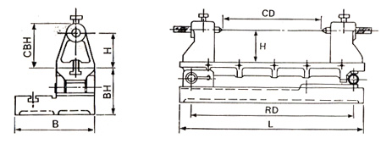
Specifications:
Height of Centres | H | 100 or 150
Centre Distance | CD | 300 (max)
Roller Distance | RD | 500
Overall Dimensions | L x B | 500 x 210
Base Height | BH | 125
Centre Blocks Height | CBH | 125or 175

